
THE RISE AND FALL OF NOKIA

Analytics: Principles and Application

Prepared By
Sainath Gagireddy
Ram Pochammala
Siddharth Patel
Sudheer Bangunde
04/20/2016

Abstract

Nokia can trace its roots back to 1865 and a pulp mill in south-west Finland. A century and a half later, Nokia's handset business is being bought by Microsoft for €5.44bn after a troubled few years for the mobile phone giant. Here we track Nokia's rise, and subsequent fall. Nokia Group is the world's largest mobile phone manufacturer with sales in more than 150 countries with an operating profit of €2 billion by 2010. Nokia is dominant across the world with the exception of North America.

Contents
Abstract 2
Introduction 4
Timeline 4
Nokia’s Technology Success 7
Analysis of Sales 8
Apple Sales Effect on Nokia 11
Android Effect 14
Key Findings 15
Conclusion & Recommendations 16
Bibliography 17

List of Tables
Table 1: Timeline of Nokia (Monaghan, 2013) 7
Table 2 Smartphone market share 2011 – 2015 7

List of Figures
Figure 1: Global market share held by Nokia 2010 to 2013 8
Figure 2: Nokia's net sales from 2009 to 2014 (in billion euros) 9
Figure 3: Global Market Share 10
Figure 4: Nokia Sales 2001 -2009 11
Figure 5: Share Prices of Apple and Nokia Post 2007 12
Figure 6: Net Sales by Major Markets 13
Figure 7: High-End Mobile Sales Comparison 14
Figure 8: Global Handset industry Q2 2007 15
Figure 9: Global Handset Industry Q2 2013 15
Figure 10 Response of Nokia to iPhone (Rolf Strom-Olsen, 2014) 17

Introduction

Nokia is one of the most renowned companies in the world that manufactures mobile handsets for a considerable period of time. For a certain period of time, Nokia was the world leader in mobile telephones, from 1998, before its decline in 2012. What were the reasons for this decline and why did a company that was in such a commanding position make such decisions which led to their decline? Let us begin by looking at some of the facts surrounding Nokia.
Nokia was founded on May 12th, 1865 with its headquarters in Espoo, Uusimaa, Finland. In 2014, Nokia employed 61,656 people across 120 countries, conducts sales in more than 150 countries and reported annual revenues of around €12.73 billion. Nokia is also a major contributor to the mobile telephony industry, having assisted in development of the GSM and LTE standards, and was, for a period, the largest vendor of mobile phones in the world. Nokia's dominance also extended into the smartphone industry through its Symbian platform, but it was soon overshadowed by the growing dominance of Apple's iPhone line and Android devices. Nokia eventually entered into a pact with Microsoft in 2011 to exclusively use its Windows Phone platform on future smartphones.

Timeline

Nokia Timeline
1865 | Mining engineer Fredrik Idestam sets up a wood pulp mill at the Tammerkoski Rapids in south-western Finland.
1871 | The Nokia name is born, inspired by the Nokianvirta river on the banks of which Idestam opens a second mill.
1898 | Eduard Polón founds Finnish Rubber Works, which later becomes Nokia's rubber business, making everything from rubber boots to tyres. Nokia wellies are still made today, though not by the telecoms company.
1912 | Arvid Wickström sets up Finnish Cable Works, the foundation of Nokia's cable and electronics business.
1967 | The official merger of Nokia Ab, Finnish Cable Works and Finnish Rubber.
1979 | Nokia creates radio telephone company Mobira Oy as a joint venture with leading Finnish TV maker Salora.
1981 | Launch of the Nordic Mobile Telephone service, the world's first international cellular network, and the first to allow international roaming.
1982 | Nokia introduces the first car phone – the Mobira Senator – to the network. That same year, the Nokia DX200, the company's first digital telephone switch, goes into operation.
1984 | Nokia launches the Mobira Talkman portable car phone – a chunky piece of kit but a start.
1987 | Nokia introduces the Mobira Cityman, the first handheld mobile phone. It weighs in at 800g and comes with a price tag of 24,000 Finnish Marks (about £3,400). The Soviet leader, Mikhail Gorbachev, is pictured using one to make a call from Helsinki to his communications minister in Moscow.
1991 | The Finnish prime minister, Harri Holkeri, makes the world's first "global system for mobile communications" call, using Nokia equipment.
1992 | Nokia launches its first digital handheld GSM phone, the Nokia 1011. The Nokia president and chief executive, Jorma Ollila, decides to focus on mobile phones and telecommunications, and the process begins of selling off its rubber, cable and consumer electronics divisions.
1994 | Nokia launches the 2100 series, the first phones to feature the Nokia Tune ringtone. It goes on to sell 20m phones worldwide in the 2100 series. Nokia's target had been 400,000.
1998 | Nokia becomes the world leader in the mobile phones market.
1996-2001 | Nokia's turnover increases almost fivefold from €6.5bn to €31bn.
1999 | Nokia launches the Nokia 7110, a phone capable of rudimentary web-based functions, including email. It uses the Orange network to access the internet using Wireless Application Protocol (WAP).
2000 | Nokia does a deal with music publisher EMI enabling users to choose their favourite tunes as their ringtones.
2001 | Nokia launches its first phone with a built-in camera, the Nokia 7650. But a profits warning, blamed on a slowdown in the mobile market, stuns investors. It announces plans to cut 1,000 jobs, but things start to look up by the end of the year.
2002 | Nokia launches its first video capture phone, the Nokia 3650. It also launches its first 3G phone, the Nokia 6650. With 3G technology, phones can now be used to browse the web, download music, watch TV on the move, and more.
2004 | Nokia reveals that although it is still the market leader it is losing share to its rivals, with its 35% share comparing with a target of 40% as it falls behind with its new product range.
2005 | Nokia sells its billionth phone – a Nokia 1100 – in Nigeria, and global mobile phone subscriptions pass 2bn.
2007 | Nokia is forced into one of the world's largest product recalls after it admits the batteries in 46m phones could be faulty. Meanwhile, a longer-term problem emerges: Apple launches the iPhone.
2008 | Nokia reports a 30% fall in third-quarter profits. Nokia smartphone sales fall by 3.1% during the quarter, while sales of Apple iPhones grow by 327.5%.
2009 | Nokia announces plans to cut 1,700 jobs worldwide as the recession hits mobile phone sales. Nokia admits it was slow to react to the rise of new devices such as the iPhone and plans to fight back. But it is too late to avoid the first loss in more than a decade.
2010 | Competitors such as the iPhone and Android-based devices are posing a serious challenge to Nokia's future. It appoints former Microsoft man Stephen Elop as president and chief executive. Nokia cuts a further 1,800 jobs despite a rise in profits.
2011 | Elop warns staff "we are standing on a burning platform", and announces a strategic partnership with Microsoft days later to compete with Apple and Google's Android platform. Nokia cuts a further 4,000 jobs worldwide from its 65,000-strong workforce. Elop denies it is in talks about a takeover by Microsoft. Nokia is overtaken by Samsung and Apple in the smartphone sector as profits and sales dwindle. Nokia launches new smartphones.
2012 | Nokia cuts 4,000 jobs and moves smartphone manufacturing to Asia. Shares fall following a profits warning and it slumps to a €1.3bn loss. Analysts foresee a possible takeover by Microsoft as it cuts 10,000 more jobs and announces its last factory in Finland will close.
2013 | Nokia returns to profit after an 18-month spell of losses. Microsoft buys Nokia's handset business for €5.44bn (£4.6bn).
Table 1: Timeline of Nokia (Monaghan, 2013)
All these details about Nokia provide a clear picture of how the company started and how it turned out over the years.

Nokia’s Technology Success
Nokia was pioneer in technology. Nokia had great achievement and this shows Nokia did not lose because Nokia was technically challenged. Companies in market use the same models to success in today’s market.
  - Sell the phones using phone carriers. – sell phone using third party was new at the time but doing so you can long term customers.
  - “Software is also as important as hardware in phone business.” – Software is important as Symbian was first OS. Keep the software similar so customer changes the phone doesn’t have to learn from scratch.
  - Phone can be much more than communication device. – Mobiles we with games(Snake), email, ringtone, colander, and may other applications.
  - Nokia had created Product Obsolescence. – Keep changing the mobile models. As one with camera, video camera, radio, more ring tones and keep customers asking for more phone.
- Nokia created first successful mobile platform as Symbian.
- In future Nokia became the first company to create the tablet with internet in it.
- Nokia was also the first company to provide online music using phones and third party as online provider again not Apple.
- Nokia also created phone with touch screen.

Analysis of Sales

The following graph shows the global market share held by Nokia with respect to sales of mobile phones to end users from the first quarter of 2010 to the most recent financial quarter. In the first quarter of 2010, Nokia had a global market share of 34.2 percent of the mobile device market and was the leading mobile device manufacturer worldwide.
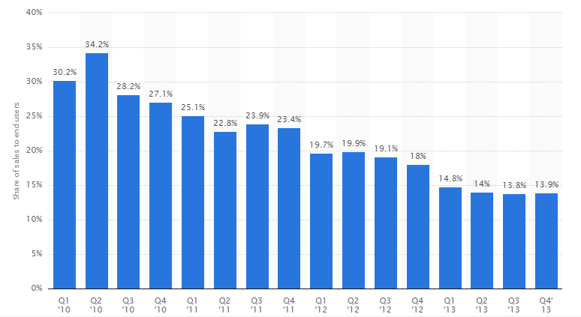
Figure 1: Global market share held by Nokia 2010 to 2013
The following chart shows Nokia's quarterly net sales from 2009 to 2014. In the first quarter of 2009, Nokia reported net sales of approximately 9.27 billion euros. Most recently sales revenue has been decreasing.
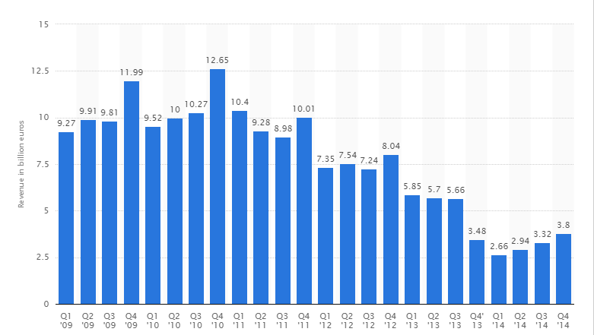
Figure 2: Nokia's net sales from 2009 to 2014 (in billion euros)
Nokia reported net sales of approximately 12.65 billion euros during the last quarter of 2010.
The following chart shows the global market share for Nokia and other mobile giants from 2008 – 1st half of 2013. After analyzing this chart, it becomes very clear that Nokia’s decline started right from 2008 with the advent of other mobiles.
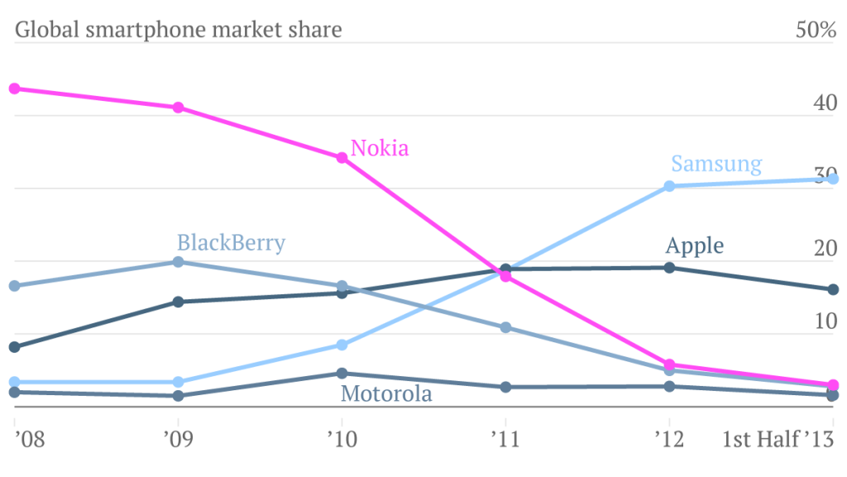
Figure 3: Global Market Share
As we can see from the above chart, Samsung grew its market share, Apple maintained a steady market share but Nokia completely lost its edge in the global market.
Before the entry of Apple into the market, the next chart will show the net sales, operating profit and net profit of Nokia from 2001 – 2009. Again, this chart will provide a clear picture of what Nokia had before the advent of high-end mobile phones.
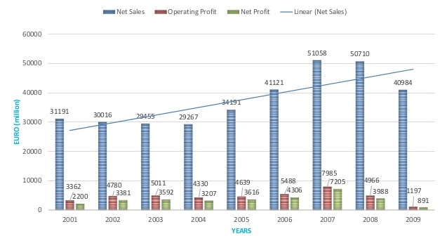
Figure 4: Nokia Sales 2001 -2009
As we can see from the chart, there was a steady rise in the net sales, operating profits and net profits from 2004-2007. After that period, Nokia saw a huge fall in its sales.

Apple Sales Effect on Nokia
Apple had a great effect on the sales of Nokia. Nokia did not consider Apple to be a competitor until it was very late and the sales of Nokia completely dropped. The following chart will show the performance of the Nokia’s stocks after Apple introduced iPhone in 2007.
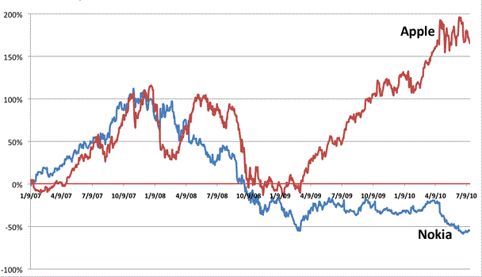
Figure 5: Share Prices of Apple and Nokia Post 2007
The chart above indicates that Apple’s share prices increased steadily after 2009 and during this period Nokia’s stock prices deceased considerably. Within a span of 6 months of the introduction of iPhone, Apple’s stock price were similar to that of Nokia.
Nokia was gaining the market share as 40% in 2009 but Nokia was losing the markets as North America, Europe and gaining market in Latin America.

Figure 6: Net Sales by Major Markets

Apple’s iPhone is considered as a high-end mobile device and Nokia’s N series mobile phones are the high-end mobile phones for the company. The next chart will show the high-end mobile phone sales for Apple and Nokia during Q3 of 2008 – Q1 of 2010. This graph is very critical as it shows the decline in the sales of Nokia even in the high end mobile phone market.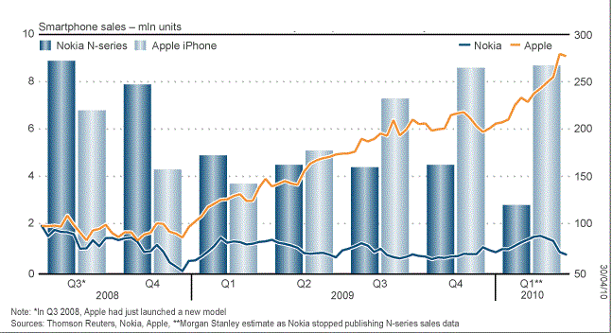
Figure 7: High-End Mobile Sales Comparison
As we can see from this chart, Apple’s iPhone sales increased right from the first quarter of 2009 before overtaking the sales of Nokia in the second quarter of 2010.

Android Effect

In 2007, Google launched Android and started an Open Handset Alliance. Motorola, Samsung, HTC, Sony and many other companies struggling at the time joined and started manufacturing Smartphones with Android. Nokia, blackberry and Apple trusted their software and OS and decide not to join the alliance. Competition in Mobile Market was increasing and to keep up with it Nokia decided to create cheaper phone and cover more market share. With the other companies in the market the phone keeps getting cheaper and cheaper and this commoditizes mobile/smart phone market. Profits in cheap mobile market keep getting reduced. Hence, in 2009, Nokia had good sale, and 40% market share but Nokia didn’t make big any profits.
The next chart compares the global handset industry particularly for two quarters, Q2 2007 and Q2 2013.
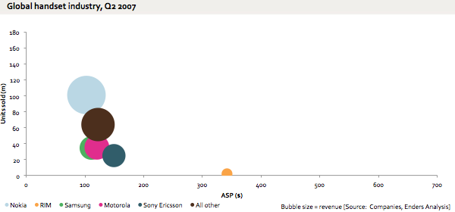
Figure 8: Global Handset industry Q2 2007
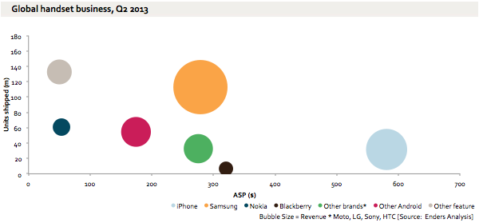
Figure 9: Global Handset Industry Q2 2013
From these bubble charts, the decline in Nokia’s handsets in the global market is very clear.

Key Findings

Right from the beginning of the year 2007, with the introduction of the iPhone from Apple, problems seems to arise in the company. iPhone sales increased by a tremendous 300% and sales of Nokia dropped by nearly 4%. This is the decline of Nokia. Although it had the resources to be on top, it could not use them effectively to come up with a product that would support them in retaining their position.
Operating System | Market Share 2011 | Market Share 2015
Windows Phone 7 / Windows Mobile | 5.5% | 20.9%
Symbian | 20.9% | 0.2%
iOS | 15.7% | 15.3%
Blackberry | 14.9% | 13.7%
Android | 39.5% | 45.4%
Table 2 Smartphone market share 2011 – 2015
Nokia’s market share dropped below 30% in the first quarter of 2011. One of the major reasons for this is the fact that, Symbian applications are not so advanced like iOS apps and Android apps.
The major drawback that Nokia faced during this period is that it could not keep up with the technological advancements and applications that Android and iOS had offered to consumers. Mobile handsets with those operating system had more to offer to their consumers but Nokia’s Symbian had limited functionality. After being unable to compte in the market with Android and iOS devices, Nokia took to Windows Mobile in 2011. Eventually, this move led to Microsoft buying Nokia in 2013 and now all the devices will be rolled out in the name of Microsoft. According to us, the rise of Apple played a major role in the decline of Nokia.

Figure 10 Response of Nokia to iPhone (Rolf Strom-Olsen, 2014)

Conclusion & Recommendations

Following are some of the conclusions that could be made from the case of Nokia.
- Was unable to stay in the competition with Android and iOS devices.
- Made mistake to capture more market share with cheap phones.
- Quality/luxury phone Market share was low.
- Going with Microsoft Windows after the failure with Symbian OS.
- Did not consider Apple to be a competitor until three years after its release.

Bibliography
Monaghan, A. (2013, September 3). Nokia: the rise and fall of a mobile phone giant. Retrieved from http://www.theguardian.com/: http://www.theguardian.com/technology/2013/sep/03/nokia-rise-fall-mobile-phone-giant
Rolf Strom-Olsen, S. M. (2014). The Extraordinary Rise and Rather Undistinguished Decline of Nokia. Madrid: Critical Perspectives on Management.

